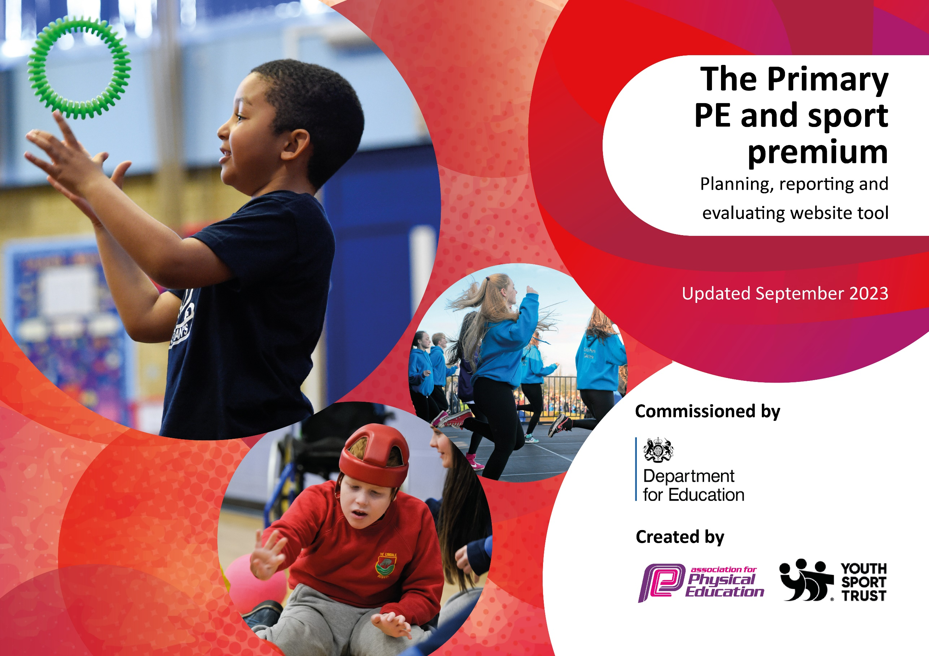

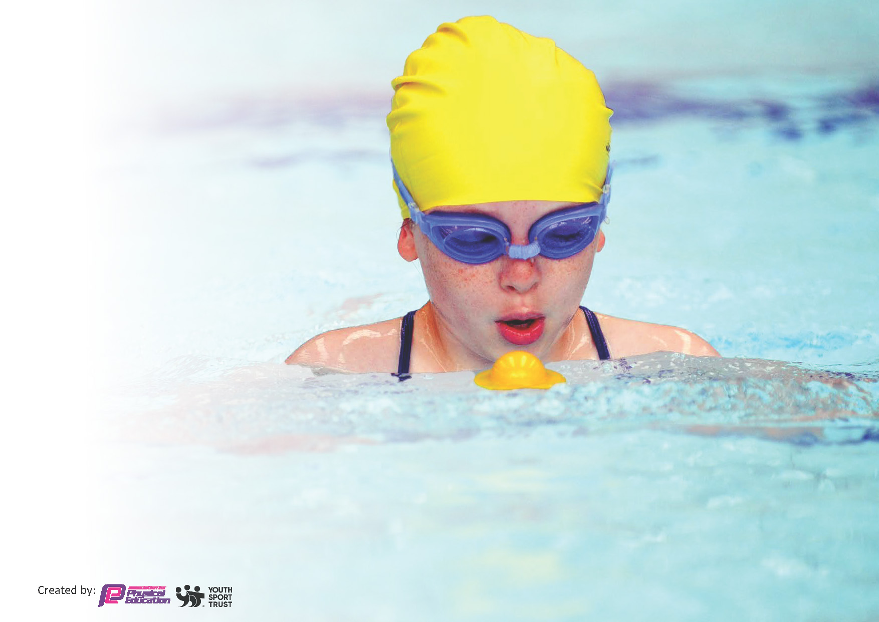
This template can be used for multiple purposes:
by:
- It enables schools to effectively plan their use of the Primary PE and sport premium
- It helps schools to meet the requirements (as set out in guidance) to publish information on their Primary PE and sport premium
- It will be an effective document to support Ofsted inspections enabling schools to evidence progress in Physical Education (PE) and evidence swimming attainment, which forms part of the PE National Curriculum. We would recommend schools consider
the Intent, Implementation and Impact of any spend, as examined within the Education Inspection Framework.

It is important that your grant is used effectively and based on school need.

Schools must use the funding to make additional and sustainable
improvements to the quality of the PE, School Sport and Physical Activity (PESSPA)
they offer. This means that you should use the Primary PE and sport premium to:

- Build capacity and capability within the school to ensure that improvements made now will benefit pupils joining the school in future years
- Develop or add to the PESSPA activities that your school already offers.

The Primary PE and sport premium should not be used to fund capital spend projects; the school’s core budget should fund these. Further detail on capital expenditure can be found in the updated Primary PE and sport premium guidance.

The Primary PE and sport premium guidance, outlines 5 key priorities that funding should be used towards. It is not

necessary that spending has to meet all the key priorities, you should select the priorities that you aim to use any funding towards.

Although completing this template is not a requirement for schools, schools are required to publish details of how they spend this funding. Schools must also outline what the impact this funding has had on pupils’ PE and sport participation and attainment and how any spending will be sustainable in the future. All funding must be spent by 31st July 2024.

The Department for Education has worked closely with the Association for Physical Education (afPE) and the Youth Sport Trust (YST) to develop this template and encourages schools to use it. This template is an effective way of meeting the reporting requirements of the Primary PE and sport premium.
Review of last year’s spend and key achievements (2022/2023)

We recommend you start by reflecting on the impact of current provision and reviewing your previous spend.

Activity/Action | Impact | Comments
Real Legacy PE Training  Real PE team teach observations with Real PE Lead | Teachers gained confidence in delivering Real PE to their classes. Consequently, a high standard of PE was achieved across the school, with ongoing steps identified for further improvement. | We will reduce this time next year, to enable us to continue to sustain community links with HTFC, whilst also using premium to develop other areas. This is with the view to returning to refresh training in the future.

Key priorities and Planning
This planning template will allow schools to accurately plan their spending.

Action – what are you planning to do | Who does this action impact? | Key indicator to meet | Impacts and how sustainability will be achieved? | Cost linked to the action
Enhance lunchtime physical activity programs to boost inclusivity and participation, incorporating play leaders.  Expand competition opportunities and increase student participation.  Provide staff with CPD training in Balanceability. | Lunchtime staffing.  Increased physical activity for leaders and younger children.  Increased opportunities for physical activity for those children identified as not accessing after school clubs.  A broad range of children including SEND, PP.  Access for all R/Y1 children to learn to ride a bike.  Staff in R and Y1 trained.  nvest in additional bike storage facilities. | Key indicator 2 -The engagement of all pupils in regular physical  Key indicator 4: Broader experience of a range of sports and activities offered to all pupils.  Key indicator 5: Increased participation in competitive sport  Key indicator 2 -The engagement of all pupils in regular physical | Increased physical activity levels for both play leaders and younger children.  Expanded opportunities for physical activity for children who were not participating in after-school clubs.  Established connections with Red Kite Schools and NYSS, for ongoing future events.  Staff received training to ensure flexible and sustainable annual bike-riding instruction for children. | Soft playground footballs £50.39  Football goals £100  Egg & spoons: £30  Stickers: £24  Bike shed: £503.99  Balanceability training: £905  Pedal Bike: £351

Harrogate Town FC CPD: Premier League Primary Stars. Class teachers to develop PE delivery and confidence.  Y6 Bike Ability Training  Retain Real PE curriculum offer | Class teachers  All pupils Year2-Year 6  Year 6 pupils  All pupils | Key Indicator 1: Increased confidence, knowledge, and skills of all staff in teaching PE and sport.  Key indicator 5: Increased participation in competitive sport.  Key indicator 4: Broader experience of a range of sports and activities offered to all pupils. | Staff trained in delivering PE lessons, specified to their identified areas of development.  Y6 children learnt to ride safely on the roads, level 1+2, encouraging healthy lifestyles.  Real PE website and equipment, ensuring all classes can access full curriculum offer with confidence. | HTFC Premier League Primary Stars: £13,280  NYCC: £108  Create Development: £695  Coloured spots: £54.95  Air cushions: £180

Key achievements 2023-2024
This template will be completed at the end of the academic year and will showcase the key achievements schools have made with their Primary PE and sport premium spending.

Activity/Action | Impact | Comments
Competition Events Calendar  This was a key priority as interschool competitions had decreased due to Covid-19. However, we have successfully participated in a range of competitions this year, including Panathlon, dance, football, rounders, and athletics. This calendar of events has helped to re-engage students in competitive sports, foster school spirit, and provide diverse opportunities for physical activity and skill development.  Delivery of Balanceability  To enhance sustainability, Reception and Year 1 staff completed comprehensive training and invested in new bike storage facilities. These sessions were delivered weekly during the summer term, with additional after-school sessions provided. As a result, more children have gained confidence in their cycling abilities, promoting physical fitness and environmental awareness. The initiative has also laid a strong foundation for lifelong cycling skills among our pupils. | We achieved high levels of participation from boys and girls across all groups, including PP (Pupil Premium), EAL (English as an Additional Language), and SEND (Special Educational Needs and Disabilities). This inclusive approach has also inspired many children to join local clubs, further extending their engagement in physical activities beyond school.  Staff have become significantly more confident in developing children's abilities to balance, control, and ride bikes. This progress is supported by well-defined resources, meticulous planning, and a clear progression path, ensuring effective and consistent instruction.  . | We ran events through the summer term and will capitalise on the high interest and participation in the new academic year.  All children were riding with good confidence by the summer.

Swimming Data
Meeting National Curriculum requirements for swimming and water safety.
Priority should always be given to ensuring that pupils can perform safe self-rescue even if they do not fully meet the first two requirements of the National Curriculum programme of study

Question | Stats: | Further context  Relative to local challenges
What percentage of your current Year 6 cohort can swim competently, confidently and proficiently over a distance of at least 25 metres? | 88% | The local swimming pool has recently re-opened after being closed for a year.  Lack of Access to Facilities:  With the local swimming pool closed for a year, pupils lost access to essential facilities for swimming lessons and practice.  Limited Alternatives:  Finding alternative pools wasnot possible, due to distance, availability, and capacity constraints.
What percentage of your current Year 6 cohort can use a range of strokes effectively [for example, front crawl, backstroke, and breaststroke]? | 44% | The combination of the swimming pool closure and disruptions caused by COVID-19 exacerbates the learning loss in physical education.  This combination has made it harder for pupils to catch up. This has impacted the number of pupils who can swim confidently using a range of strokes.

What percentage of your current Year 6 cohort are able to perform safe self-rescue in different water-based situations? | 44%
If your schools swimming data is below national expectation, you can choose to use the Primary PE and sport premium to provide additional top-up sessions for those pupils that did not meet National Curriculum  requirements after the completion of core lessons. Have you done this? | Yes/No
Have you provided CPD to improve the knowledge and confidence of staff to be able to teach swimming and water safety? | Yes/No

Head Teacher: | Hannah McNamara
Subject Leader or the individual responsible for the Primary PE and sport premium: | Emma Baxter PE Lead
Governor: | Richard Selfridge
Date: | 25.07.24

